**Software Requirements Specification**

**for**

Wholesale App

**Version 1.0 approved**

**Prepared by Celine Tan, Foo Jin Rui, Tan Yu, Zaki bin Zainuddin**

**SC2006**

**11/1/2022**

# Table of Contents

**Table of Contents ii**

**1. Introduction 1**

1.1 Purpose 1

1.2 Document Conventions 1

1.3 Intended Audience and Reading Suggestions 1

1.4 Product Scope 1

1.5 References

**2. Overall Description 2**

2.1 Product Perspective 2

2.2 Product Functions 2

2.3 User Classes and Characteristics 2

2.4 Operating Environment 2

2.5 Design and Implementation Constraints 2

2.6 Assumptions and Dependencies 3

**3. External Interface Requirements 3**

3.1 User Interfaces 3

3.2 Hardware I nterfaces 11 3

3.3 Software Interfaces 3

3.4 Communications Interfaces

**4. Functional Requirement 12**

**5. Non-functional Requirement 14**

5.1 Performance Requirement 14

5.2 Usability Requirement 14

5.3 Reliability Requirement 14

5.4 Security Requirement 14

5.5 Maintainability Requirement 14

**6. Use Case Diagram 15**

**7. Use Case Description 16**

**8. Class Diagram 29**

**9. Sequence Diagram 30**

9.1 Create Unique Account 30

9.2 Create Stall Page 31

9.3 Search Hawker Stalls Based on Filters 32

9.4 Leave Review 33

**10. Dialog Map 34**

**11. System Architecture Diagram 35**

**12. System Design 36**

**13. Testing 37**

13.1 Black Box Testing 37

13.2 White Box Testing38

**Appendix A: Data Dictionary 42**

# Introduction

## Purpose

This SRS document covers the function of the application, Wholesale App, which serves as a one stop platform for hawker businesses in Singapore to gain exposure and help them grow. It also serves as a platform for customers to find hawker foods they might be interested in.

## **Document Conventions**

This SRS document is adapted from the IEEE standard for Software Requirements Specification.

## **Intended Audience and Reading Suggestions**

This document is intended for the ZEA evaluators of the Data-Driven Smart Nation Competition, as well as the respective designers and developers of Wholesale App.

The rest of the SRS will contain mostly the functional and the non-functional requirements of the application, as well as relevant diagrams to gain clarity on the flow of the function.

Readers should focus mainly on the functional requirements here as it will provide an insight into the main use cases for the eventual product, and its usability in addressing the primary purpose of the application.

## **Product Scope**

The purpose of our software application is to revitalise the hawker food industry in Singapore. This is accomplished by creating a one stop platform for customers to rate and share about their local hawker food experiences, and for hawker store owners to promote their businesses while keeping track of the progress of their stalls. It encourages hawkers to gain digital literacy, through the use of a web application connected to cloud storage, and enables them to improve their businesses by receiving real-time feedback.

# Overall Description

## **Product Perspective**

This application was designed due to the lack of platforms available to allow hawker stalls to gain exposure. Currently, many hawker stalls are either not registered, or are simply outshined by modern restaurants’ presence on food reviews and recommendations platforms. Coupled with the fact that many Singaporean customers, in the digital age, prefer to check reviews of an establishment before dining there. These factors put hawker stalls at a severe disadvantage. This application aims to become the tool that shines a light on these traditional businesses.

## Product Functions

a) Hawker Owners must be able to create more than one stall profile.

b) Customers must be able to search local hawker stalls based on location and dietary

specifications.

c) Customers must be able to rate hawker stalls and leave reviews.

d) Customers must be able to locate hawker stalls of their choice.

## User Classes and Characteristics

The following user classes are anticipated to be largely involved in the usage of our application. Their importance is ranked by the order of mentioning below:

a) Hawker Owners: Hawker Owners are most inclined to use Wholesale App to promote

and track the progress of their businesses.

b) Locals: Locals can discover new food options by leveraging on Wholesale App.

c) Tourists: Tourists who are in search of authentic local food can use Wholesale App to

streamline their decision making process.

## Operating Environment

Wholesale app is designed and expected to be operational in the following atmosphere:

a) Internet Explorer, Microsoft Edge, Google Chrome, Firefox, or Safari downloaded onto

their Mac, Windows or Linux platform.

b) Ability for internet connectivity

## Design and Implementation Constraints

The design and implementation constraints include:

a) The application front-end shall be developed using Bootstrap framework .

b) The application back-end framework shall be developed using Django framework

c) The application scripts which are written in python shall be implementing web scraping

techniques and API calls to fetch the required data from Google Maps and data.gov.sg.

## Assumptions and Dependencies

The assumptions and dependencies include:

a) The hawker owner does not does not provide false information about his/her hawker

stall(s).

b) The hawker owner does not create replicates of the same stall profile.

c) The customer does not manipulate the ratings/reviews of any hawker stall.

d) The usage of Google Maps API will be cost-free indefinitely.

e) The usage of data.gov.sg API will be cost-free indefinitely.

f) The application will be able to run in future updates of Windows, Mac and Linux operating systems.

# External Interface Requirements

## User Interfaces

Within the application, a top navigation bar should be displayed at every page to allow the user to easily navigate between different utility tabs.

Error messages should appear at the sign up page when the user has entered an active username or an insecure password. The user should be disallowed from creating an account if he/she fulfils any of the below criteria:

* Password must be more than 8 characters
* Password cannot be too common
* Password must contain lowercase alphabets, uppercase alphabets, and numbers
* Password cannot be the same as the username
* Password must be unique

Error messages should appear at the login page when the user has entered incorrect credentials, and the user should be disallowed from entering the application if he/she does not have the correct credentials*.*

For a mock-up of the customer interface, please refer to figures 3.1.1 to 3.1.5.

For a mock-up of the hawker interface, please refer to figures 3.1.6 to 3.1.8.

For a mock-up of the login page, please refer to figures 3.1.9 to 3.1.10.

For a mock-up of the map page, please refer to figures 3.1.11.

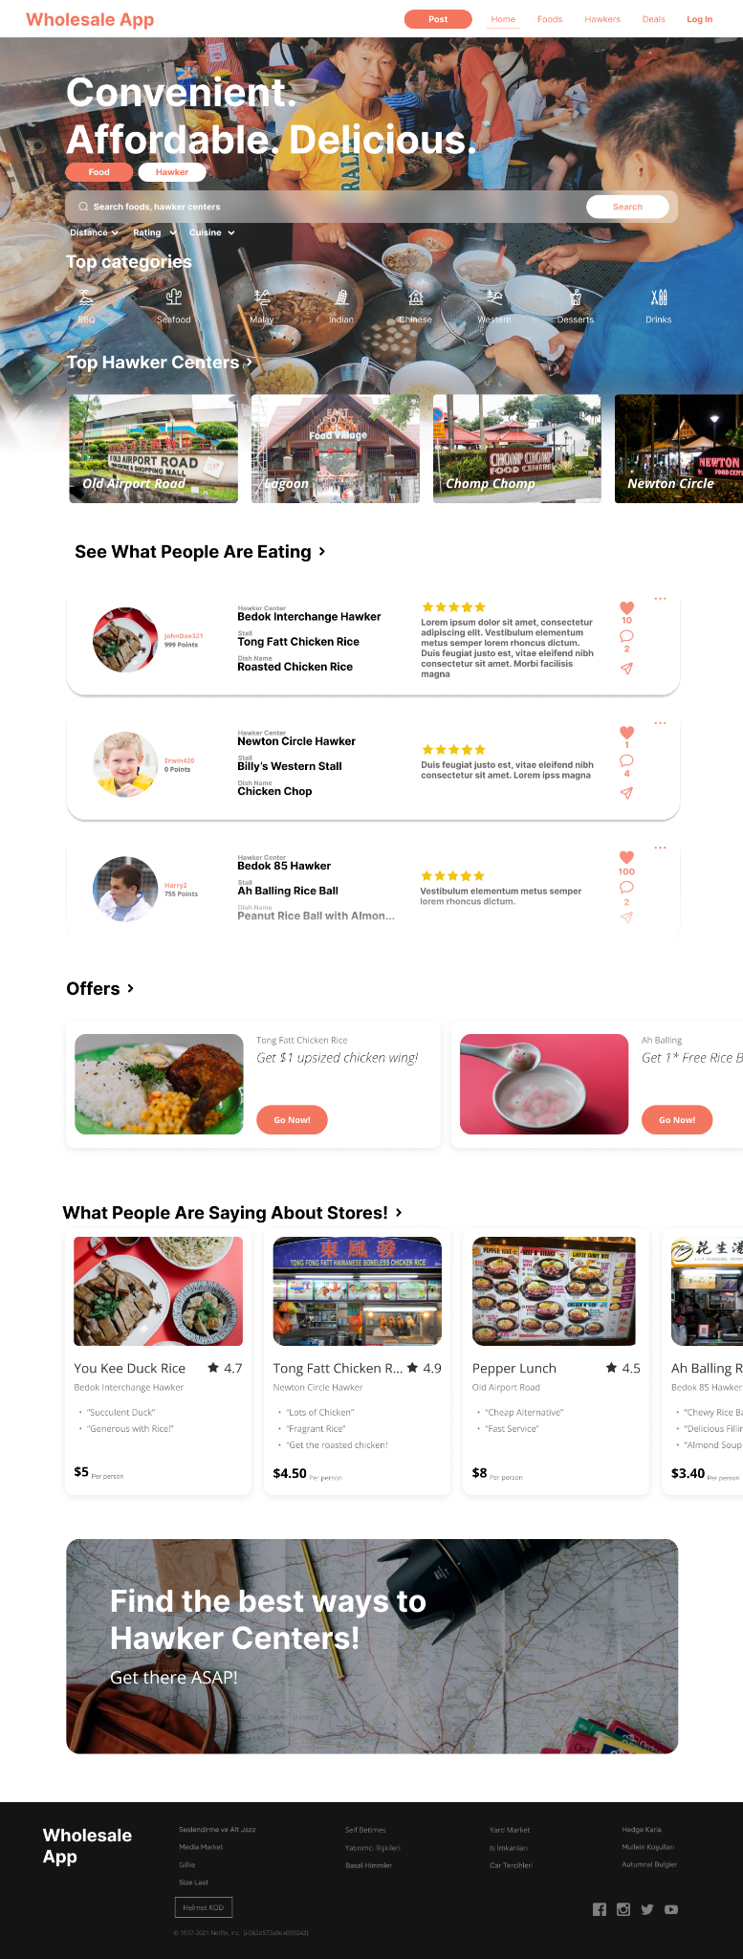

*Figure 3.1.1. Customer’s View of Home Page*

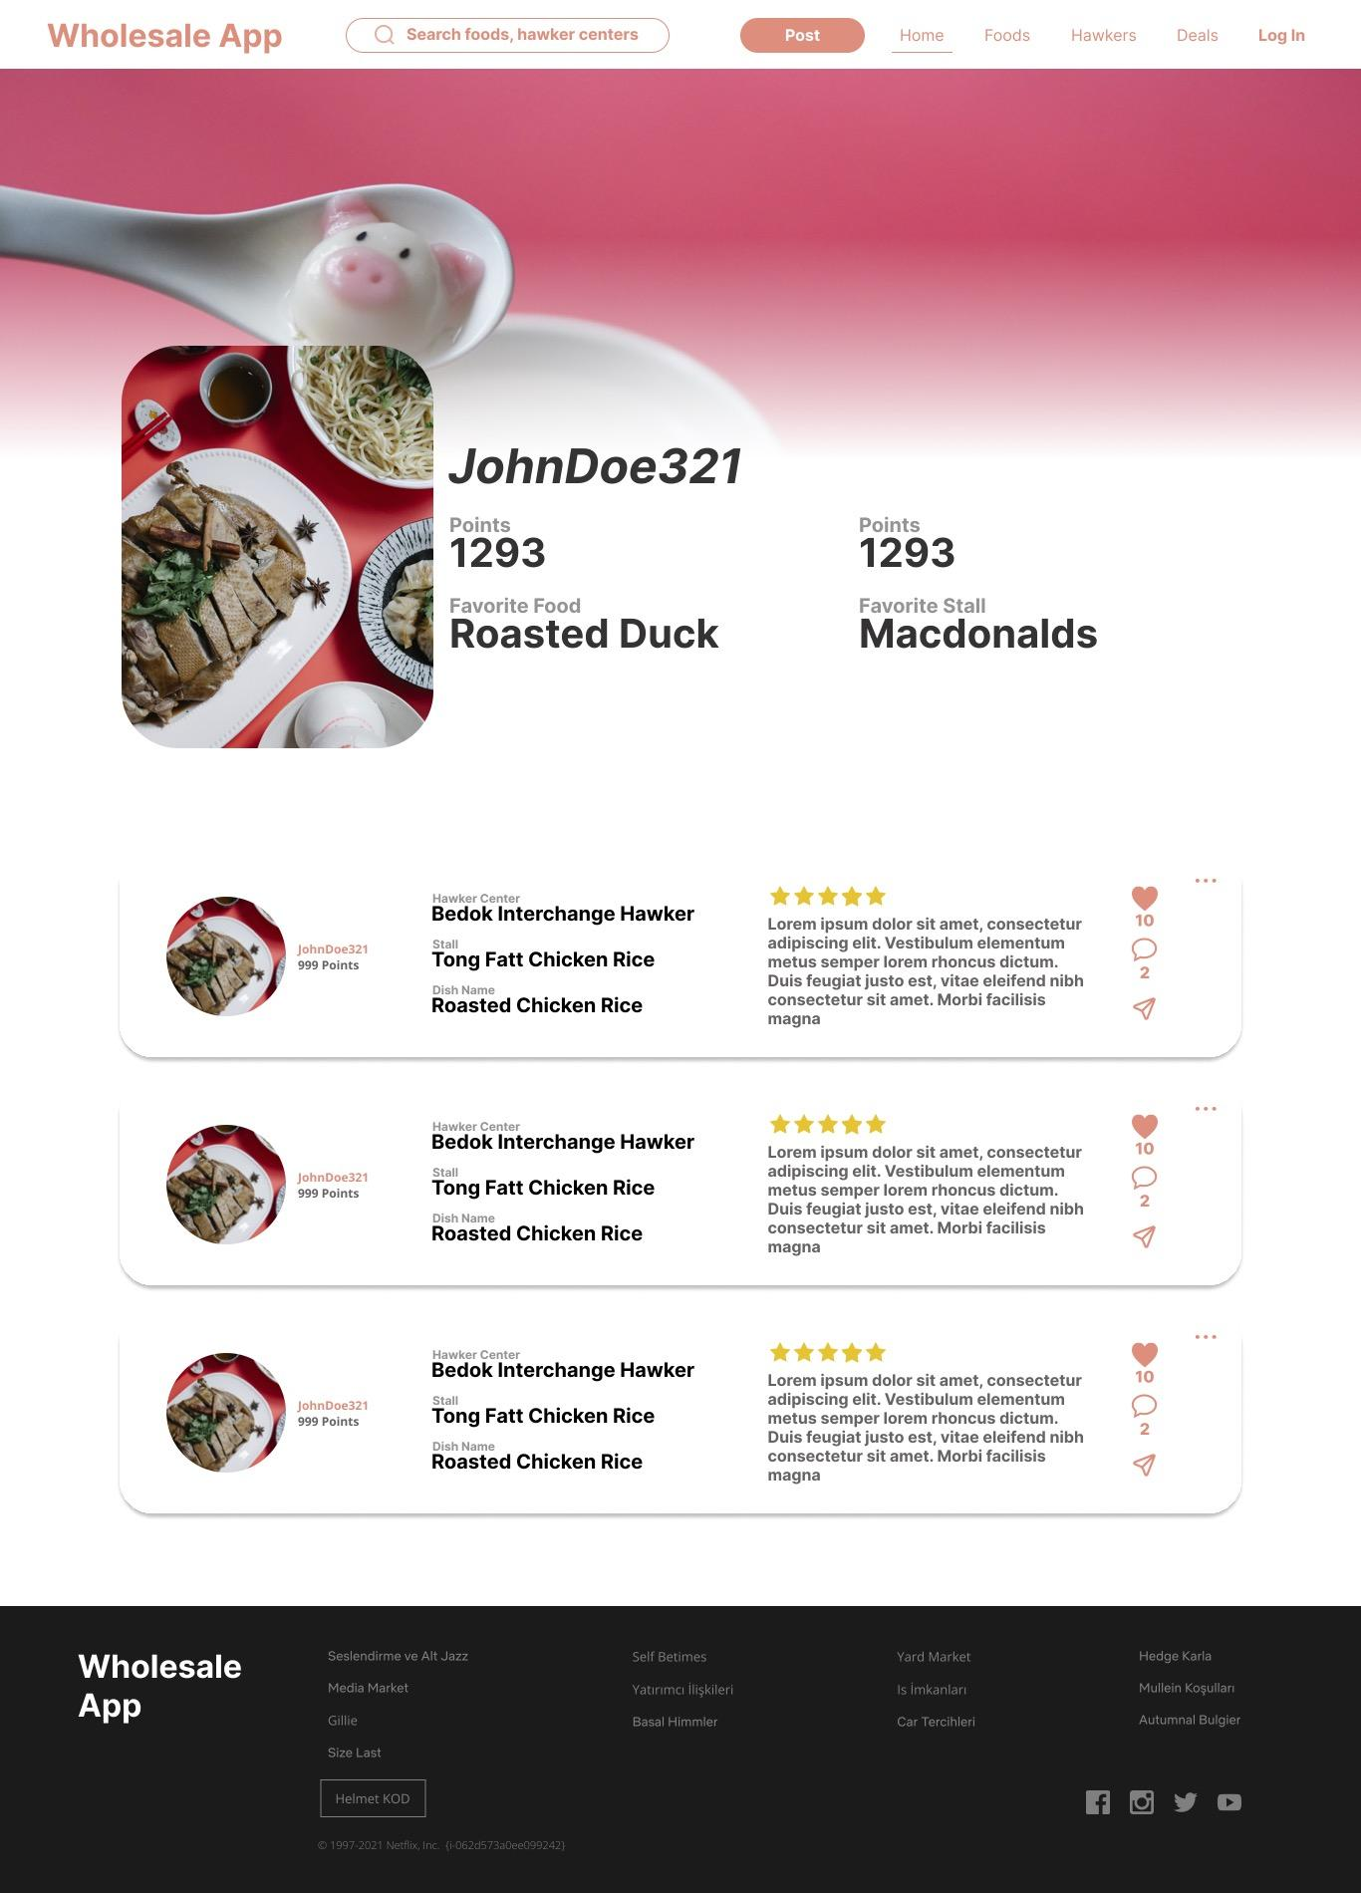

*Figure 3.1.2. Customer’s View of Customer Profile Page*

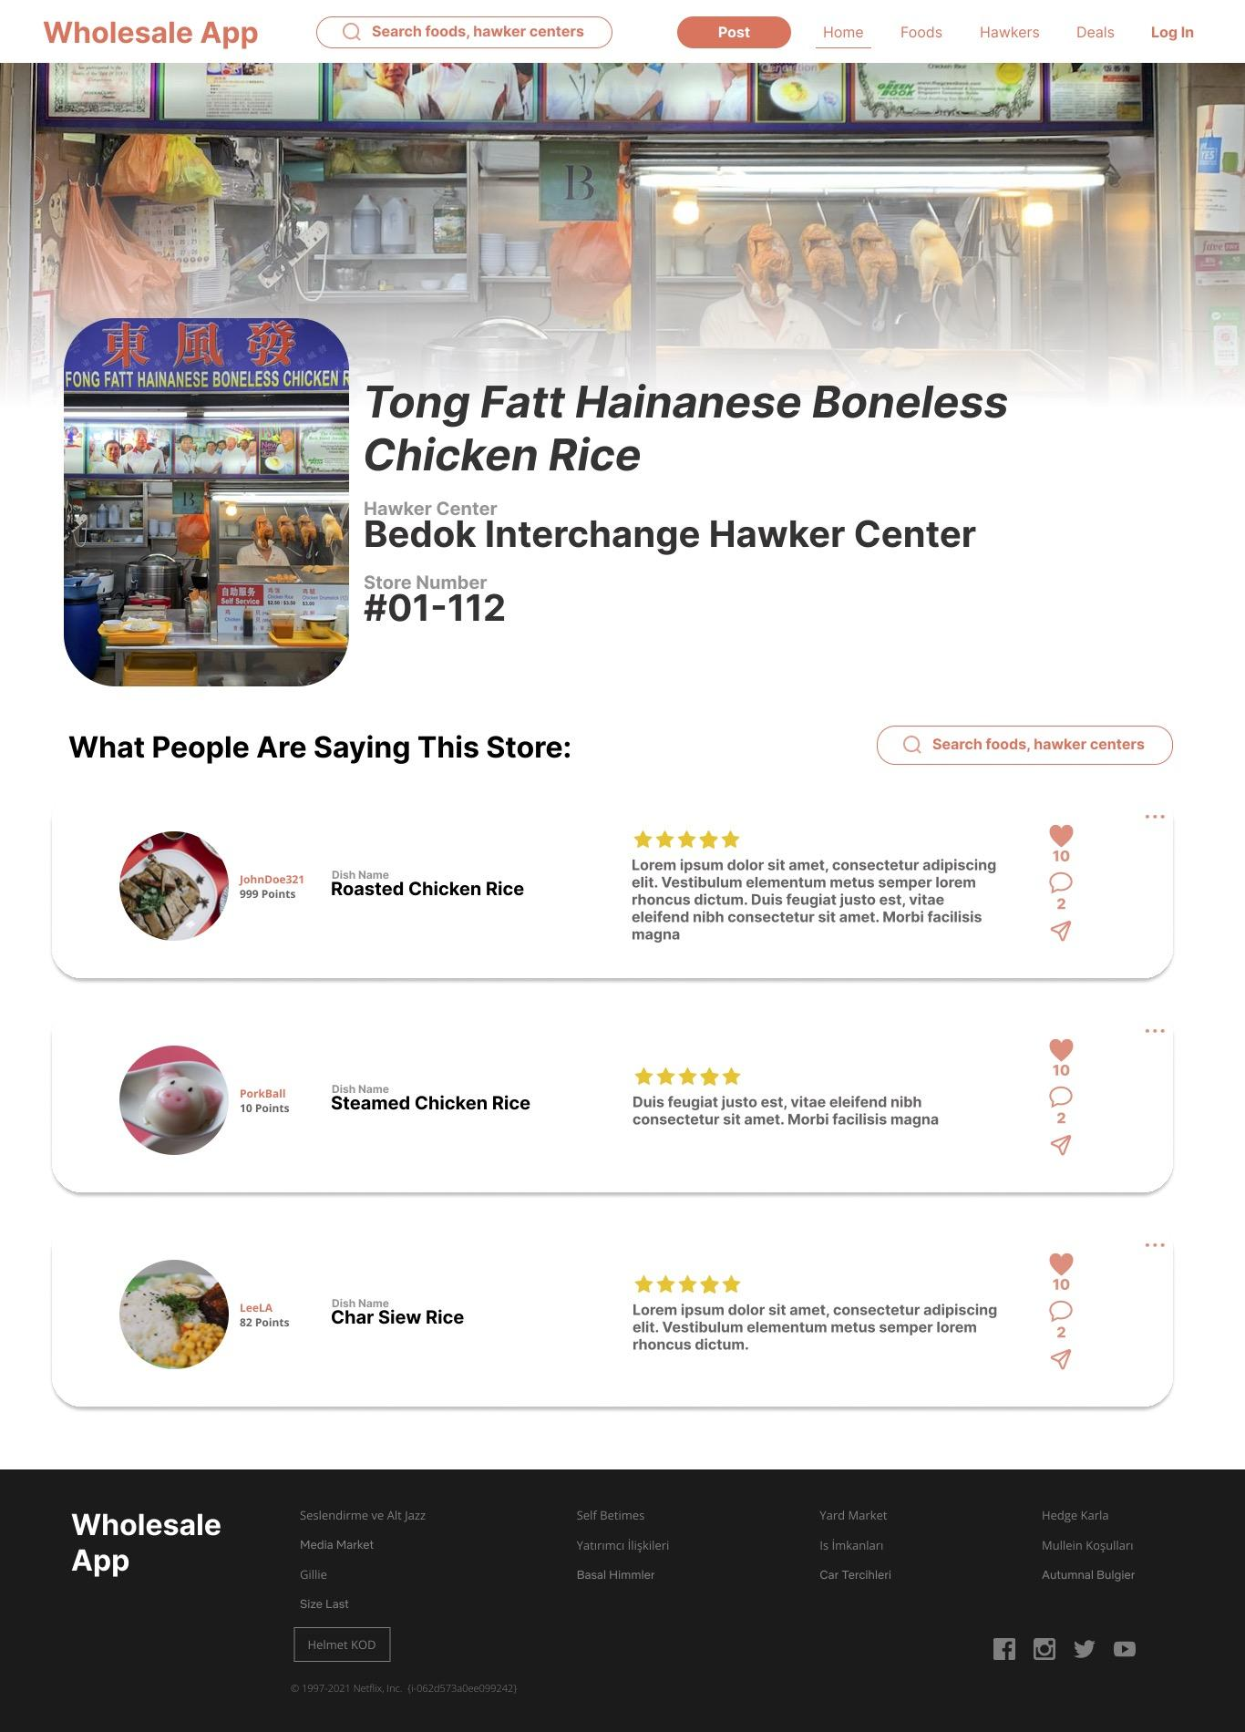

*Figure 3.1.3. Customer’s View of Hawker Profile Page*

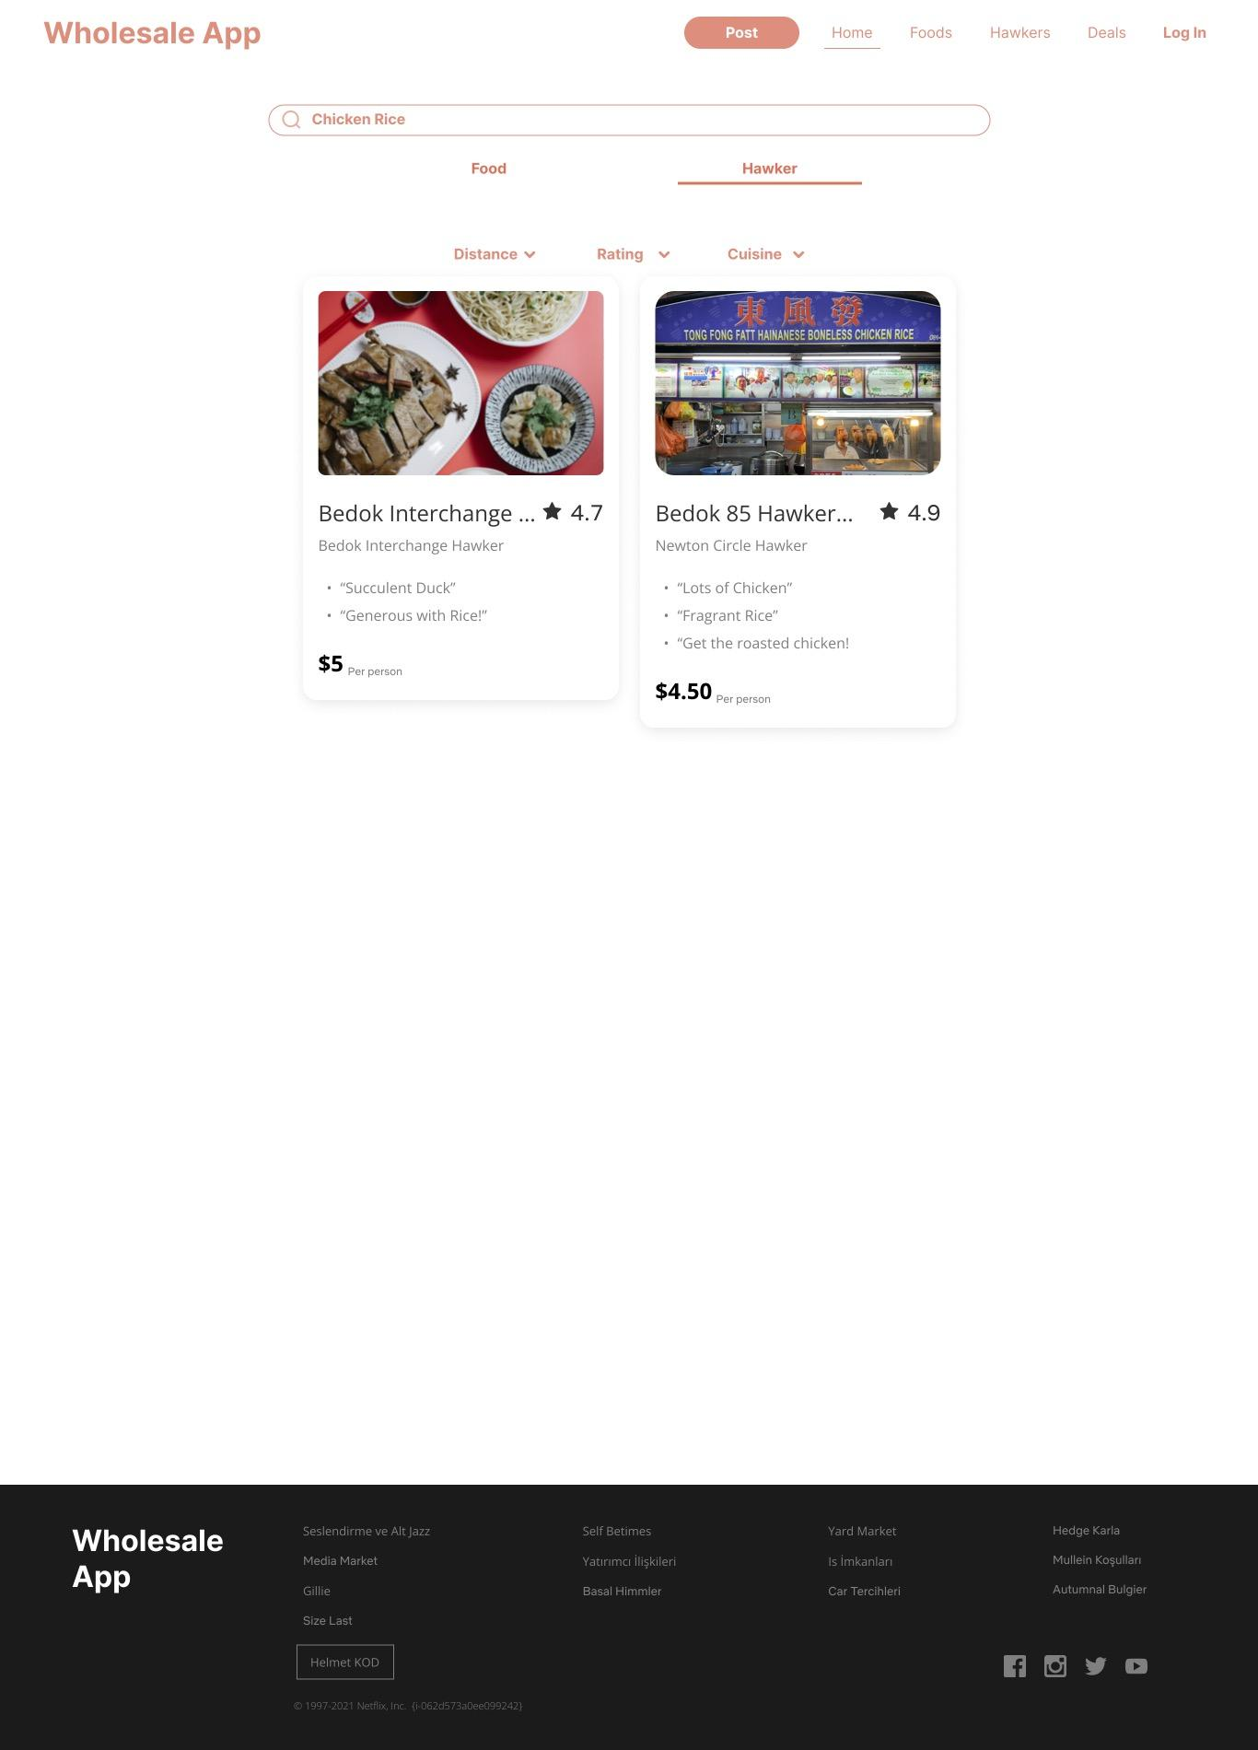

*Figure 3.1.4. Customer’s View of Search Page*

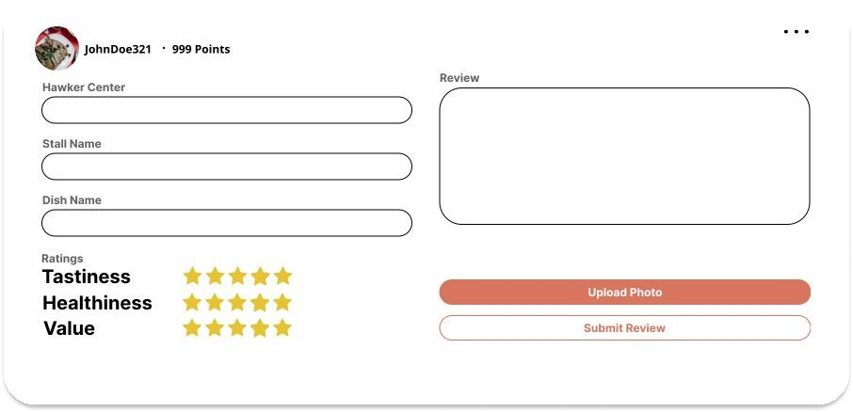

*Figure 3.1.5. Customer’s View of Review Form*

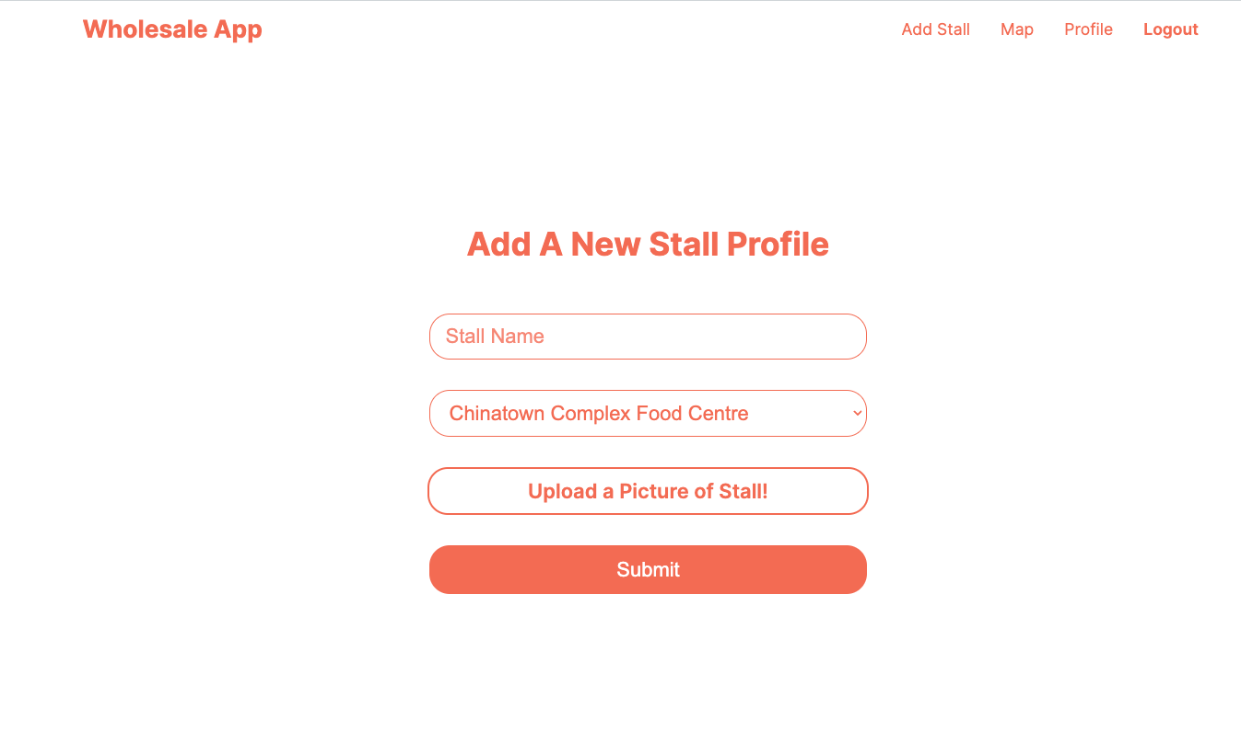

*Figure 3.1.6. Hawker’s View of Add Stall Form*

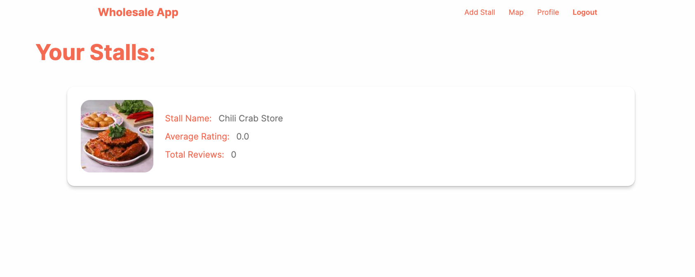

*Figure 3.1.7. Hawker’s View of Hawker Profile*

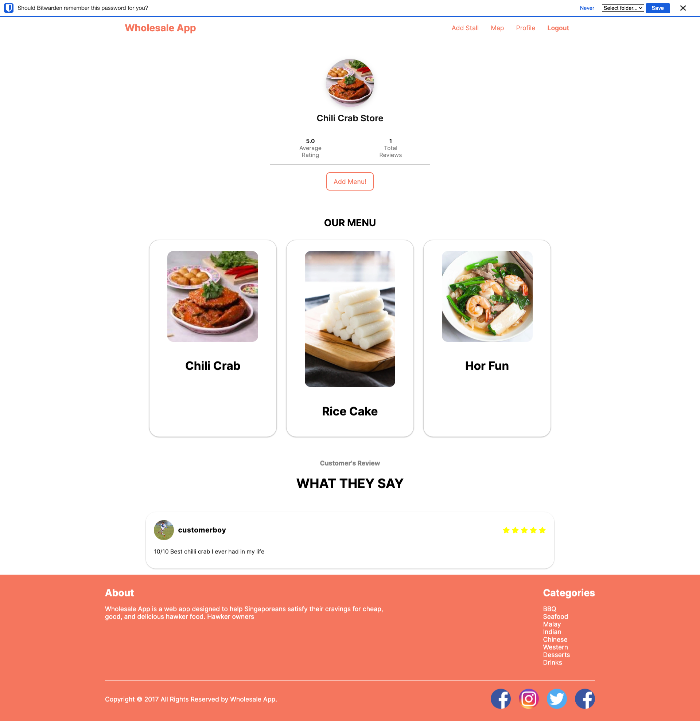

*Figure 3.1.8. Hawker’s View of Hawker Stall Profile*

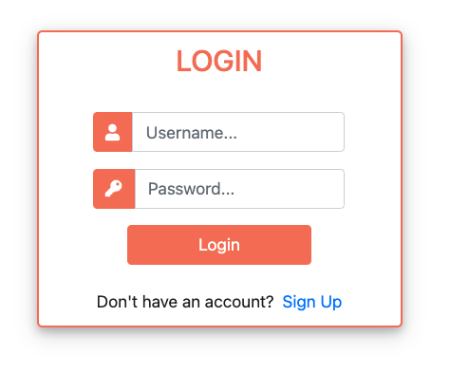

*Figure 3.1.9. Login Form*

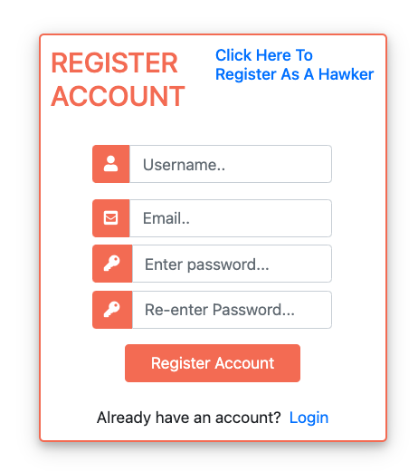

*Figure 3.1.10. Registration Form*

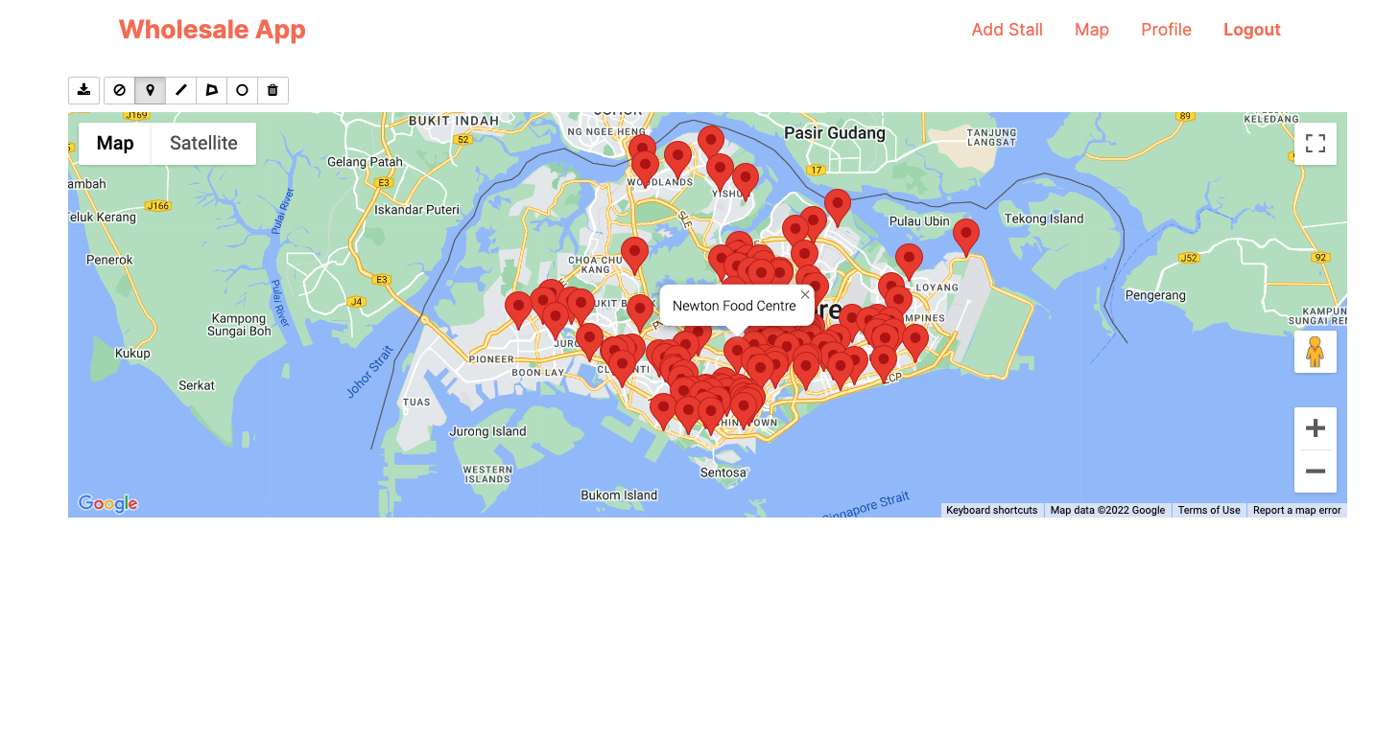

*Figure 3.1.11. Map Page*

## Hardware Interfaces

This product will only be usable on Windows, Mac and Linux operating systems.

## Software Interfaces

Wholesale App is being designed to work on any web browser. Wholesale App receives information on location of hawker centres from data.gov.sg database and navigation to the hawker centres from Google Maps as well as location of user from GPS. When users use the hawker map, the map will retrieve location of the hawker centres from data.gov.sg database. While users want to get navigation to the hawker centres of their choice, Wholesale App will direct them to Google Maps for route planning process.

## Communications Interfaces

This product will be deployed on the Hypertext Transfer Protocol Secure (HTTPS). HTTPS secures data transfer and communication between a user's browser and a website. HTTPS is the secure version of Hypertext Transfer Protocol (HTTP). HTTPS protects users against man-in-the-middle (MitM) attacks and eavesdroppers. It also prevents domain name system (DNS) spoofing attacks on legitimate domains.

HTTPS is thus a natural choice for this product as it is recommended for websites that requires login credentials to ensure the security of users and data.

# 4. Functional Requirements

## Login Page

* 1. Users must be able to login as Customer.
  2. Users must be able to login as Hawker.

## Sign Up Page

* 1. Users must be able to sign up as Customer.
  2. Users must be able to sign up as Hawker.

## Homepage

* 1. The homepage must be able to show the top hawker centres
  2. The homepage must be able to show the most recent reviews being posted by the customer users.

## Search

* 1. Users must be able to search by hawker centres.
     1. The search result must show the available stalls in the hawker centre.
  2. Users must be able to search by food.
     1. The search result must show the available stalls selling related food.

## Map

* 1. Users able to have an overlook of the list of hawker centres in Singapore displayed in Google Map
     1. Data must be retrieved from data.gov.sg
     2. Users must be able to click on specified location

## Stall Page

* 1. Users must be able to get direction under each of the stall profiles.
     1. The website must direct users to the specific stall on google map.
  2. Users must be able to leave reviews under each of the stall profiles.
     1. Users must be able to upload photos for the reviews.

## Hawker Profile

* 1. Hawker users must be able to add different stalls under one profile.
     1. Hawker users can view the list of stall profiles added.
  2. Hawker users must be able to add a menu under each stall profile.
  3. Hawker users must be able to view the reviews posted by customer users under each stall profiles

## Customer Profile

* 1. Customer users must be able to view the reviews they have posted.

# 

# 5. Non-functional Requirements

## Performance Requirement

## The system must not crash when the user opens the application.

## The system must be able to return the display results to the user within 2 seconds

## Usability Requirement

* 1. The application design must be intuitively illustrated for easy navigation.
  2. All features of the application are clearly displayed.
  3. The system must offer informative feedback.
     1. To provide necessary feedback to the user when invalid inputs are detected.
     2. To display an appropriate error message when certain process fails.
  4. All features of the application will only be supported in the English Language.

## Reliability Requirement

* 1. The website should have an uptime of more than 98%.
  2. The system must not break due to the user’s erroneous actions.

## Security Requirement

* 1. Personal data of users should not be disclosed without permission.
  2. The password should be of length 8 with at least one letter and number.

## Maintainability Requirements

* 1. Maintenance shall be conducted monthly to ensure that the application is always up to date
  2. 3 days prior to maintenance, an electronic announcement will be released to inform the user of upcoming maintenance and updates, stating the date and time accurately.

# 6. Use Case Diagram

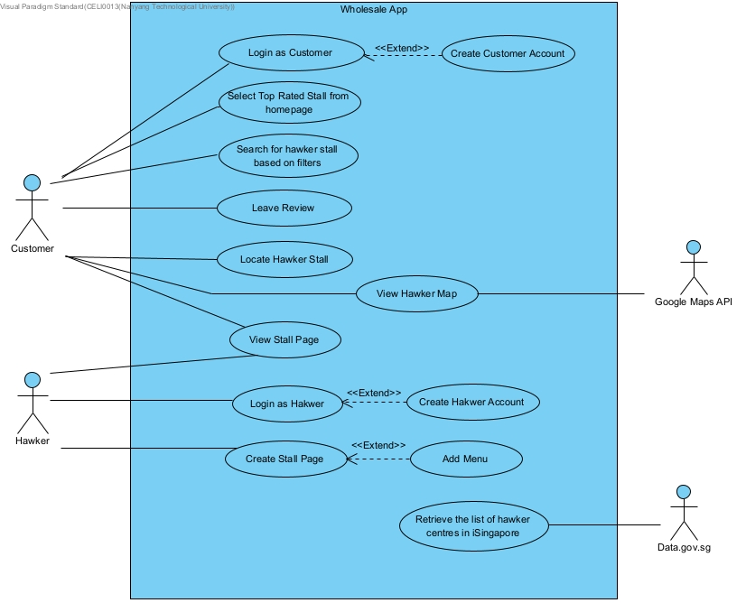

# 7. Use Case Description

| Use Case ID: |  | 1 | | |
| --- | --- | --- | --- | --- |
| Use Case Name: |  | Create a customer account | | |
| Created By: |  | Zaki | Last Updated By: | Celine Tan |
| Date Created: |  | 26 Aug 2022 | Date Last Updated: | 5 Nov 2022 |

| Actor: |  | Customer User |
| --- | --- | --- |
| Description: |  | User can sign up as customer and own a customer account. The account is transferable across devices and can be accessed remotely. |
| Preconditions: |  | 1. User must be connected to WiFi/Mobile Data 2. User must be on the “Sign Up Page” |
| Postconditions: |  | 1. User will have a unique customer profile defined by a unique account username and password |
| Priority: |  | High |
| Frequency of Use: |  | Medium |
| Flow of Events: |  | 1. User opens webpage 2. User clicks “Sign Up as Customer” 3. User enters a unique username 4. User enters their personal email 5. User enters a password 6. User re-enters a password 7. Username and password are saved into the database |
| Alternative Flows: |  | **AF-S3: Unique username already exists in the database**   1. User enters a different username 2. Return to step 3   **AF-S5: Password is not strong enough**   1. User is prompted for a different password 2. Password should contain at least 8 characters with a mixture of letters and numbers. 3. Return to step 5 |
| Exceptions: |  | - |
| Includes: |  | **-** |
| Special Requirements: |  | - |
| Assumptions |  | 1. User has a personal email |
| Notes and Issues |  | - |

| Use Case ID: |  | 2 | | |
| --- | --- | --- | --- | --- |
| Use Case Name: |  | Create a hawker account | | |
| Created By: |  | Zaki | Last Updated By: | Celine Tan |
| Date Created: |  | 26 Aug 2022 | Date Last Updated: | 5 Nov 2022 |

| Actor: |  |  |
| --- | --- | --- |
| Description: |  | User can sign up as hawker and own a hawker account. The account is transferable across devices and can be accessed remotely. |
| Preconditions: |  | 1. User must be connected to WiFi/Mobile Data 2. User must be on the “Sign Up Page” |
| Postconditions: |  | 1. User will have a unique customer profile or hawker profile defined by a unique account username and password |
| Priority: |  | High |
| Frequency of Use: |  | Medium |
| Flow of Events: |  | 1. User opens webpage 2. User clicks “Sign Up as a Hawker” 3. User enters a unique username 4. User enters their personal email 5. User enters a password 6. User re-enters a password 7. Username and password are saved into the database |
| Alternative Flows: |  | **AF-S3: Unique username already exists in the database**   1. User enters a different username 2. Return to step 3   **AF-S5: Password is not strong enough**   1. User is prompted for a different password 2. Password should contain at least 8 characters with a mixture of letters and numbers. 3. Return to step 5 |
| Exceptions: |  | - |
| Includes: |  | **-** |
| Special Requirements: |  | - |
| Assumptions |  | 1. User has a personal email |
| Notes and Issues |  | - |

| Use Case ID: |  | 3 | | |
| --- | --- | --- | --- | --- |
| Use Case Name: |  | Log into customer account using username and password | | |
| Created By: |  | Zaki | Last Updated By: | Celine Tan |
| Date Created: |  | 26 Aug 2022 | Date Last Updated: | 05 Nov 2022 |

| Actor: |  | Customer User |
| --- | --- | --- |
| Description: |  | Customer user logs into customer account using a unique username and password.. |
| Preconditions: |  | 1. User must be connected to WiFi/Mobile Data 2. User must have an account 3. User must be on the “Login Page” |
| Postconditions: |  | 1. Customer user is able to log into their account and retrieve their information 2. Customer user is able to search for hawker stall of his/her choice. 3. Customer user is able to leave reviews |
| Priority: |  | High |
| Frequency of Use: |  | Medium |
| Flow of Events: |  | 1. User enters their username 2. User enters their corresponding password 3. User clicks “Login” button 4. Information is validated against database 5. User logs in successfully |
| Alternative Flows: |  | **AF-S1: Username does not exist**   1. User is presented with an error message 2. User is prompted to enter their username again 3. Return to step 1   **AF-S2: Password is incorrect**   1. User is presented with an error message 2. User is prompted to enter their password again 3. Return to step 2 |
| Exceptions: |  | - |
| Includes: |  | - |
| Special Requirements: |  | - |
| Assumptions: |  | - |
| Notes and Issues: |  | - |

| Use Case ID: |  | 4 | | |
| --- | --- | --- | --- | --- |
| Use Case Name: |  | Log into hawker account using username and password | | |
| Created By: |  | Tan Yu | Last Updated By: | Celine Tan |
| Date Created: |  | 05 Sep 2022 | Date Last Updated: | 05Nov 2022 |

| Actor: |  | Hawker User |
| --- | --- | --- |
| Description: |  | Hawker user logs into their account using a unique username and password. |
| Preconditions: |  | 1. Hawker user must be connected to WiFi/Mobile Data 2. Hawker user must have an account 3. Hawker user must be on the “Login Page” |
| Postconditions: |  | 1. Hawker user is able to log into their account and retrieve their information 2. Hawker user is able to add stall profile 3. Hawker user is able to add menu under each of the stall profile |
| Priority: |  | High |
| Frequency of Use: |  | Medium |
| Flow of Events: |  | 1. User enters their username 2. User enters their corresponding password 3. User clicks “Login” button. 4. Information is validated against database 5. User logs in successfully |
| Alternative Flows: |  | **AF-S1: Username does not exist**   1. Hawker is presented with an error message 2. Hawker is prompted to enter their username again 3. Return to step 3   **AF-S2: Password is incorrect**   1. Hawker is presented with an error message 2. Hawker is prompted to enter their password again 3. Return to step 4 |
| Exceptions: |  | - |
| Includes: |  | **-** |
| Special Requirements: |  | - |
| Assumptions: |  | - |
| Notes and Issues: |  | - |

| Use Case ID: |  | 5 | | |
| --- | --- | --- | --- | --- |
| Use Case Name: |  | Select top rated hawker centres | | |
| Created By: |  | Zaki | Last Updated By: | Celine Tan |
| Date Created: |  | 26 Aug 2022 | Date Last Updated: | 05 Nov 2022 |

| Actor: |  | Customer User |
| --- | --- | --- |
| Description: |  | User is shown recommendations of hawker centres based on ratings. |
| Preconditions: |  | 1. User must be connected to WiFi/Mobile Data 2. User must be on the “Homepage” |
| Postconditions: |  | 1. User can view a list of top rated hawkers |
| Priority: |  | Medium |
| Frequency of Use: |  | High |
| Flow of Events: |  | 1. User scrolls through the list of top rated hawker centres 2. User is presented with hawker stalls rated 4 stars and above. 3. User click on the interested hawker centre. 4. User will be shown list of available stalls in the specific hawker centre. |
| Alternative Flows: |  | **AF-S4: Database doesn’t contain any entries**   1. User is presented with message stating that there are no results |
| Exceptions: |  | - |
| Includes: |  | - |
| Special Requirements: |  | - |
| Assumptions: |  | - |
| Notes and Issues: |  | - |

| Use Case ID: |  | 6 | | |
| --- | --- | --- | --- | --- |
| Use Case Name: |  | Search for hawker stalls based on filters | | |
| Created By: |  | Zaki | Last Updated By: | Celine |
| Date Created: |  | 26 Aug 2022 | Date Last Updated: | 05 Nov 2022 |

| Actor: |  | Customer User |
| --- | --- | --- |
| Description: |  | Customer user searches the database of hawker stalls |
| Preconditions: |  | 1. User must be connected to WiFi/Mobile Data 2. User must be on the “Homepage” |
| Postconditions: |  | 1. User can view results pertaining to their search 2. User can gather information on related hawker stalls    1. Location    2. Menu |
| Priority: |  | Medium |
| Frequency of Use: |  | High |
| Flow of Events: |  | 1. User clicks on search bar and select the results to be filtered by hawker centres or food 2. User keys in related keywords and makes a query 3. System checks user query against database 4. User is presented with hawker stalls related to their query |
| Alternative Flows: |  | **-** |
| Exceptions: |  | - |
| Includes: |  | **Search Filter**   1. User may filter search results by    1. Hawker centres    2. Food |
| Special Requirements: |  | - |
| Assumptions |  | - |
| Notes and Issues |  | - |

| Use Case ID: |  | 7 | | |
| --- | --- | --- | --- | --- |
| Use Case Name: |  | Leave review | | |
| Created By: |  | Zaki | Last Updated By: | Celine |
| Date Created: |  | 26 Aug 2022 | Date Last Updated: | 03 Nov 2022 |

| Actor: |  | Customer User |
| --- | --- | --- |
| Description: |  | Customer users can leave reviews under stall page |
| Preconditions: |  | 1. Customer user must be connected to WiFi/Mobile Data 2. Customer user must login to their account 3. Customer user must be on hawker stall page of their choice |
| Postconditions: |  | 1. User leaves reviews under stall page 2. Other users can view the reviews |
| Priority: |  | Medium |
| Frequency of Use: |  | High |
| Flow of Events: |  | 1. User click ‘Leave your Review” button. 2. User fill in the review form. 3. User keys in review. 4. User give rating. 5. User upload an image for the review. 6. User click ‘Submit’ button |
| Alternative Flows: |  | **AF-S3: User do not key in the review**   1. User will be prompted with error message ‘Please fill out this field.’. 2. Return to step 3.   **AF-S4: User do not give rating**   1. User will be prompted with error message ‘Please fill out this field.’. 2. Return to step 4.   **AF-S5: User do not upload image**   1. User will be prompted with error message ‘Please upload a file.’. 2. Return to step 5. |
| Exceptions: |  | - |
| Includes: |  | - |
| Special Requirements: |  | - |
| Assumptions: |  | - |
| Notes and Issues: |  | - |

| Use Case ID: |  | 8 | | |
| --- | --- | --- | --- | --- |
| Use Case Name: |  | Locate Hawker Centre | | |
| Created By: |  | Foo Jin Rui | Last Updated By: | Celine |
| Date Created: |  | 05 Sept 2022 | Date Last Updated: | 03 Nov 2022 |

| Actor: |  | Customer User |
| --- | --- | --- |
| Description: |  | Customer user can get navigation from their current location to the hawker centre of their choice. |
| Preconditions: |  | 1. Customer user must be connected to Wi-Fi/Mobile Data. 2. Customer user must have location on their device enabled. 3. Customer user must be on the hawker stall page of their choice. |
| Postconditions: |  | 1. Customer user will be directed to google maps to get navigation to thehawker centre of their choice |
| Priority: |  | Medium |
| Frequency of Use: |  | Medium |
| Flow of Events: |  | 1. Customer user clicks on “Find Me” button. 2. Customer user is directed to a new page showing the live route from their location to the hawker centre. |
| Alternative Flows: |  | - |
| Exceptions: |  | - |
| Includes: |  | - |
| Special Requirements: |  | - |
| Assumptions: |  | - |
| Notes and Issues: |  | - |

| Use Case ID: |  | 9 | | |
| --- | --- | --- | --- | --- |
| Use Case Name: |  | View Hawker Map | | |
| Created By: |  | Celine Tan | Last Updated By: |  |
| Date Created: |  | 4 Nov 2022 | Date Last Updated: |  |

| Actor: |  | Customer User |
| --- | --- | --- |
| Description: |  | Customer users can have an overlook of the list of hawker centres in Singapore on Google map |
| Preconditions: |  | 1. Customer user must be connected to Wi-Fi/Mobile Data. 2. Customer user must login to their account |
| Postconditions: |  | 1. Customer user will be shown a map with hawker centres in Singapore. 2. Customer user will be shown the name of the hawker centre when click on the location. |
| Priority: |  | Medium |
| Frequency of Use: |  | Low |
| Flow of Events: |  | 1. User clicks on Map on the main menu. 2. A google map with list of hawker centres in Singapore will be shown. 3. User click on target location to retrieve the details of the hawker centre. |
| Alternative Flows: |  | - |
| Exceptions: |  | - |
| Includes: |  | - |
| Special Requirements: |  | - |
| Assumptions: |  | - |
| Notes and Issues: |  | - |

| Use Case ID: |  | 10 | | |
| --- | --- | --- | --- | --- |
| Use Case Name: |  | Create Stall Page | | |
| Created By: |  | Celine Tan | Last Updated By: | Celine Tan |
| Date Created: |  | 06 Sep 2022 | Date Last Updated: | 05 Nov 2022 |

| Actor: |  | Hawker User |
| --- | --- | --- |
| Description: |  | Hawker users can create their own stall profile page under their hawker account |
| Preconditions: |  | 1. Hawker user must be connected to Wi-Fi/Mobile Data 2. Hawker user must be logged into hawker account |
| Postconditions: |  | 1. Hawker user will have the stall profile under their account 2. Others users must be able to view the stall profile page |
| Priority: |  | Medium |
| Frequency of Use: |  | Low |
| Flow of Events: |  | 1. Hawker click ‘Add Stall’ button to add a new stall profile. 2. Hawker user keys in the name of the stall . 3. Hawker user selects the hawker centres where the stall is located. 4. Hawker user upload an image of the stall. 5. Hawker user clicks “Submit” button |
| Alternative Flows: |  | **AF-S2: User do not provide the name of the stall**   1. User will be prompted with error message ‘Please fill out this field.’. 2. Return to step 2.   **AF-S3: User do not select the hawker centres**   1. User will be prompted with error message ‘Please select this field.’. 2. Return to step 4.   **AF-S4: User do not upload image**   1. User will be prompted with error message ‘Please upload a file.’. 2. Return to step 5 |
| Exceptions: |  | - |
| Includes: |  | - |
| Special Requirements: |  | 1. Images must be of .jpg, .jpeg, or .png format |
| Assumptions: |  | - |
| Notes and Issues: |  | - |

| Use Case ID: |  | 11 | | |
| --- | --- | --- | --- | --- |
| Use Case Name: |  | Add Menu | | |
| Created By: |  | Celine Tan | Last Updated By: | Celine Tan |
| Date Created: |  | 06 Sep 2022 | Date Last Updated: | 04 Nov 2022 |

| Actor: |  | Hawker User |
| --- | --- | --- |
| Description: |  | Hawker users can add menu under their stall profile page. |
| Preconditions: |  | 1. Hawker user must be connected to Wi-Fi/Mobile Data. 2. Hawker user must login to his/her hawker account. 3. Hawker user must own a stall profile. |
| Postconditions: |  | 1. Menu with details must be shown on respective stall page 2. Other users must be able to view the menu on the stall page |
| Priority: |  | Medium |
| Frequency of Use: |  | Medium |
| Flow of Events: |  | 1. Hawker user click into stall profile under hawker profile 2. Hawker user click ‘Add Menu’ button to add menu under stall profile page 3. Hawker user add the name of the dish 4. Hawker user upload image for the dish |
| Alternative Flows: |  | **AF-S3 - Hawker user do not provide the dish name**   1. Hawker user is presented with a message stating ‘Please fill out this field’ 2. Return to Step 3   **AF-S4 - Hawker user do not upload image**   1. Hawker user will be prompted with a message stating ‘Please upload a file’ 2. Return to Step 4 |
| Exceptions: |  | - |
| Includes: |  | - |
| Special Requirements: |  | 1. Images must be of .jpg, .jpeg, or .png format |
| Assumptions: |  | - |
| Notes and Issues: |  | - |

| Use Case ID: |  | 12 | | |
| --- | --- | --- | --- | --- |
| Use Case Name: |  | View Stall Profile Page | | |
| Created By: |  | Celine Tan | Last Updated By: | Celine Tan |
| Date Created: |  | 04 Nov 2022 | Date Last Updated: | 04 Nov 2022 |

| Actor: |  | Customer user and hawker user |
| --- | --- | --- |
| Description: |  | Users can have an overview of the rating and menu of the stall of their choice. |
| Preconditions: |  | 1. User must be connected to Wi-Fi/Mobile Data 2. User must login into account |
| Postconditions: |  | 1. User will be shown the menu of the stall 2. User will be shown the reviews being posted under the stall by every users |
| Priority: |  | High |
| Frequency of Use: |  | High |
| Flow of Events: |  | 1. User click into the stall profile of his/her choice 2. User scroll through the stall profile page to check out the menu. 3. User scroll through the stall profile page to read the reviews posted by other users |
| Alternative Flows: |  | - |
| Exceptions: |  | - |
| Includes: |  | - |
| Special Requirements: |  | - |
| Assumptions: |  | - |
| Notes and Issues: |  | - |

# 8. Class Diagram

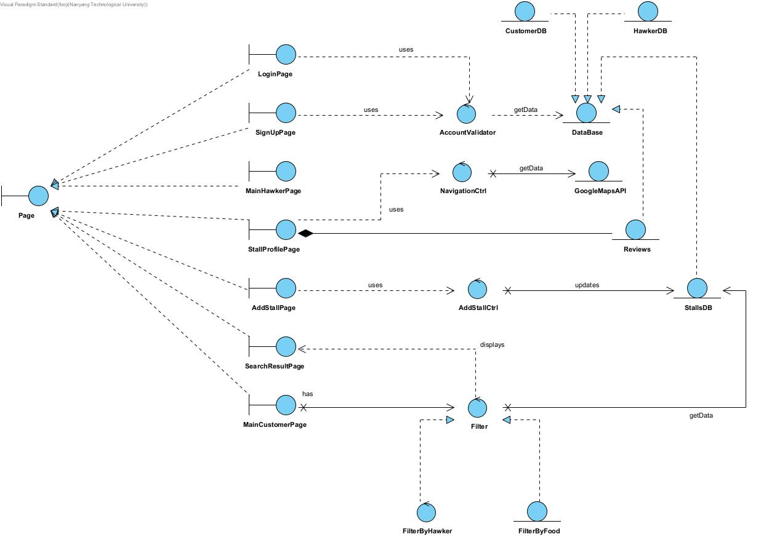

# 9. Sequence Diagram

## Create an unique account

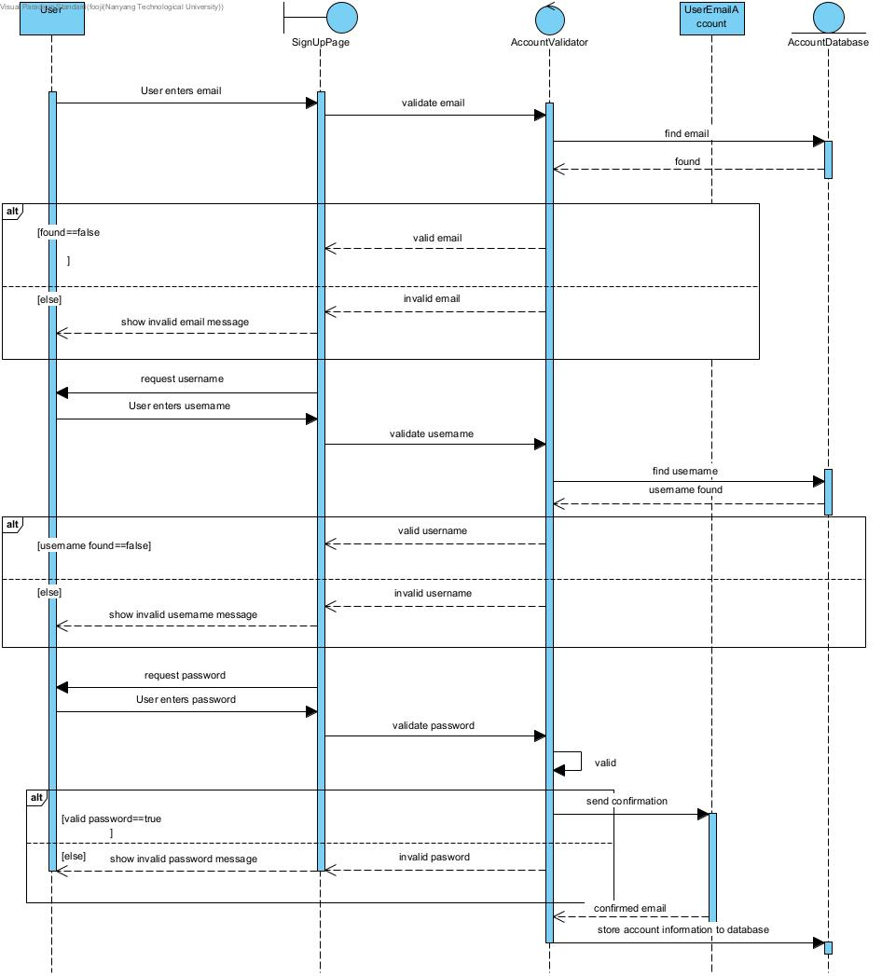

## Create Stall Profile

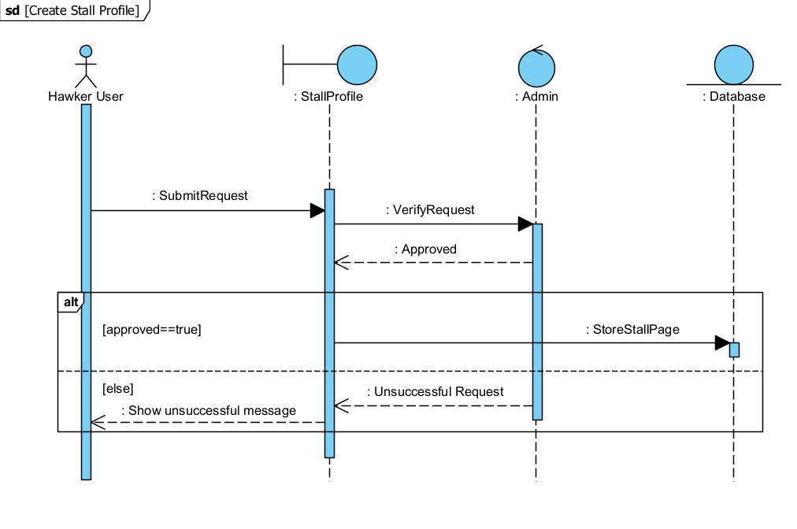

## Search hawker stalls based on filters

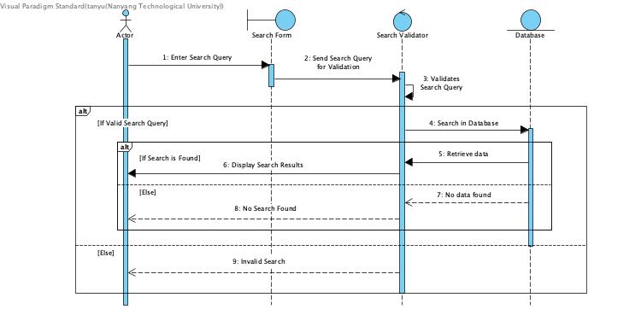

## Leave Review

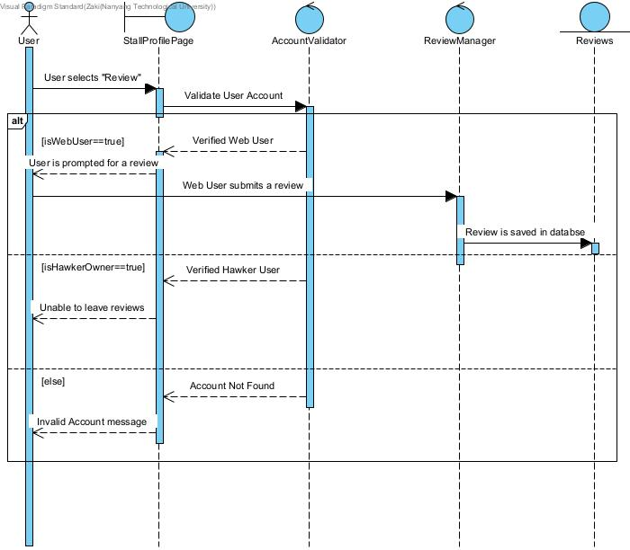

# 10. Dialog Map

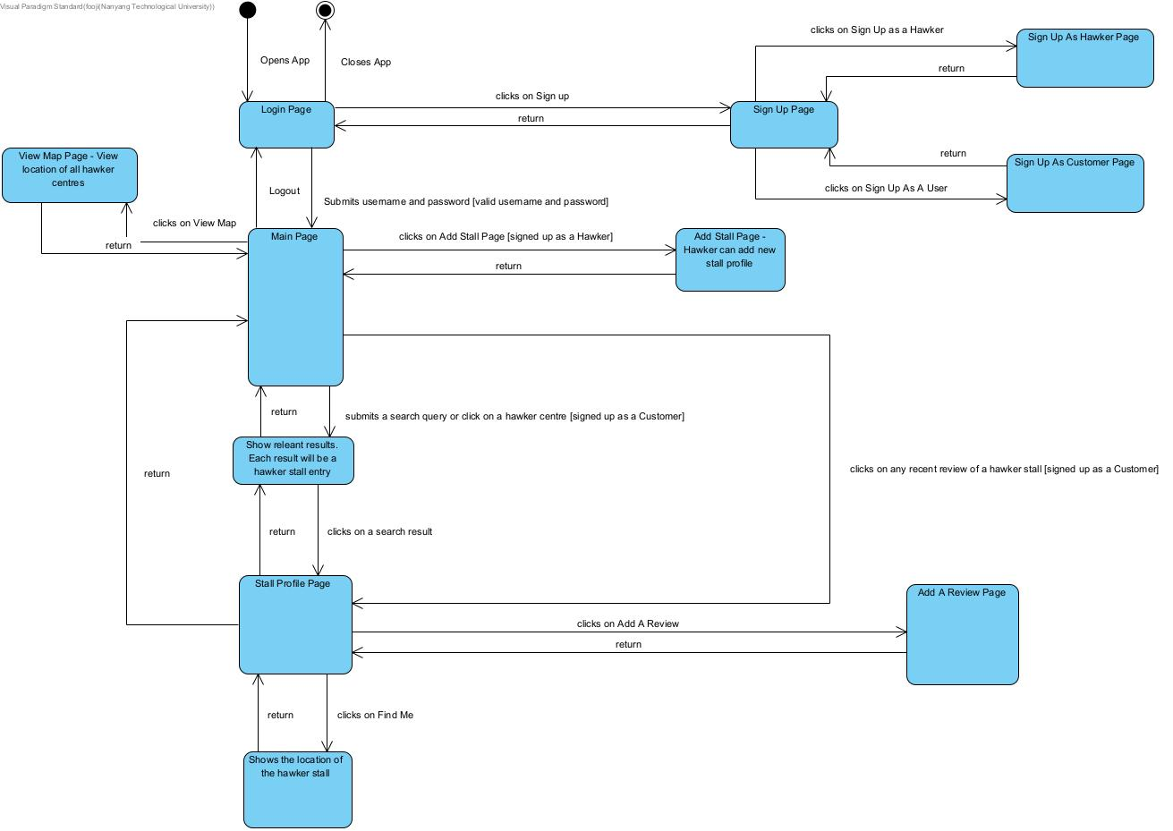

# 11. System Architecture

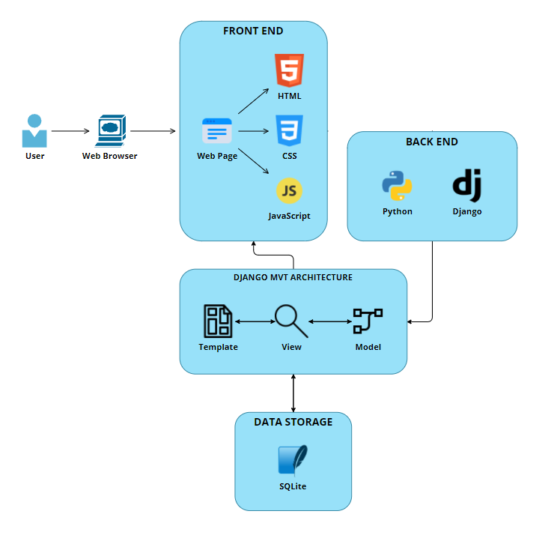

# 12. System Design

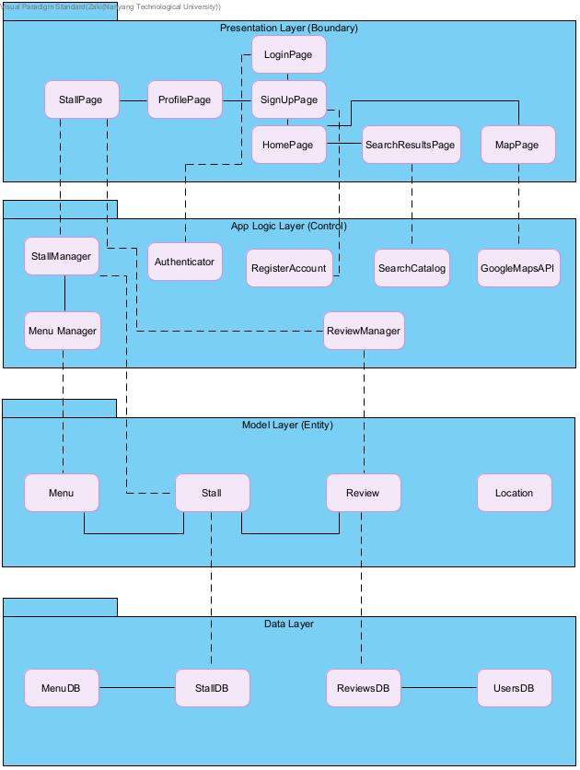

# 13. Testing

## Black Box Testing

Black box testing is performed on sign up as customer user.

Execution of test cases and documentation of result manually

| **Test Case** | **Username** | **Email** | **Password** | **Re-enter Password** | **Expected Output** | **Actual Output** |
| --- | --- | --- | --- | --- | --- | --- |
| 1 | customerboy | customerboy.gmail.com | sc2006cust | sc2006cust | Invalid Email | Invalid Email |
| 2 | customerboy | customer.boy@gmail.com | 1234 | 1234 | Password too short | Password too short |
| 3 | customerboy | customer.boy@gmail.com | sc2006cust | sc2006cust | Account successfully created | Account successfully created |
| 4 | customerboy | customer.boy@gmail.com | !2006asqw | !2006asqw | Duplicate account not created | Duplicate account not created |

## White Box Testing

Basis path testing is performed on our **login** and **search hawker stalls based on filters function**

**13.2.1 Login**

Control Flow Grapg (CFG)

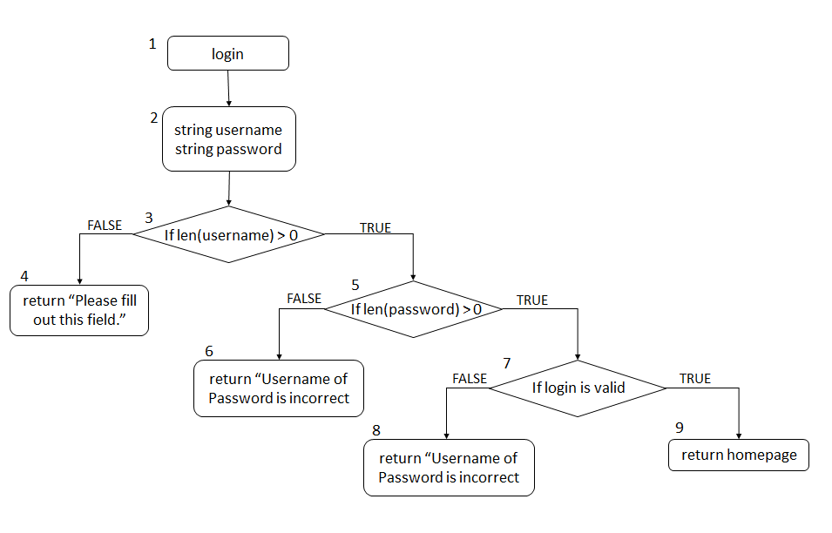

Cyclomatic Complexity

CC = |deicison nodes| + 1 = 3 + 1 = 3

Basis Paths

1. 1, 2, 3, 4
2. 1, 2, 3, 5, 6,
3. 1, 2, 4, 5, 7, 8
4. 1, 2, 4, 5, 7, 9

Test Cases

| **Path** | **Username** | **Password** | **Output** |
| --- | --- | --- | --- |
| I | “ ” | - | “Please fill out this field” on username input field |
| II | customerboy | “ ” | “Please fill out this field” on password input field |
| III | customerboy | 1234qwer | Username or Password Is Incorrect |
| IV | customerboy | sc2006cust | Homepage shown |

Code Implementation

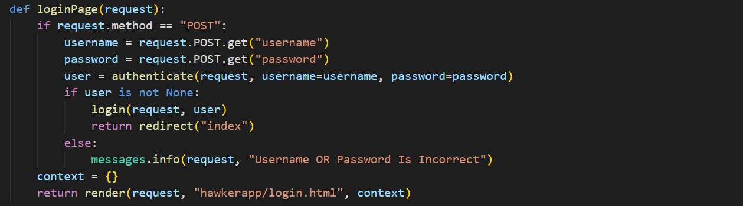

**13.2.2 Search hawker stalls based on filters function**

Control Flow Graph (CFG)

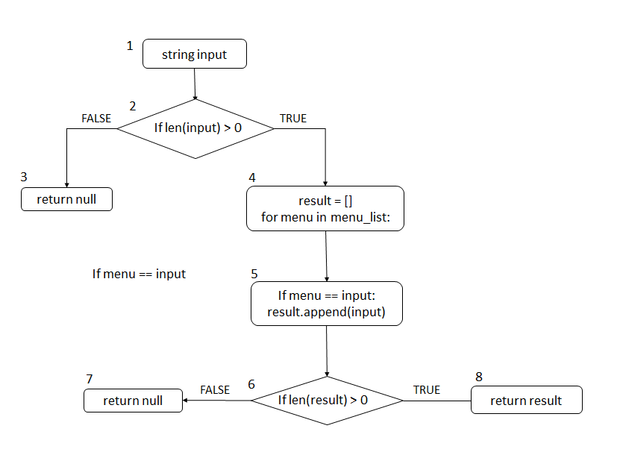

Cyclomatic Complexity

CC = |deicison nodes| + 1 = 2 + 1 = 3

Basis Paths

1. 1, 2, 3
2. 1, 2, 4, 5, 6, 7
3. 1, 2, 4, 5, 6, 8

Test Cases

| **Path** | **Input** | **Output** |
| --- | --- | --- |
| I | “ ” | No result |
| II | “rice” | List of stalls sell rice |
| III | “car” | No result |

Code Implementation

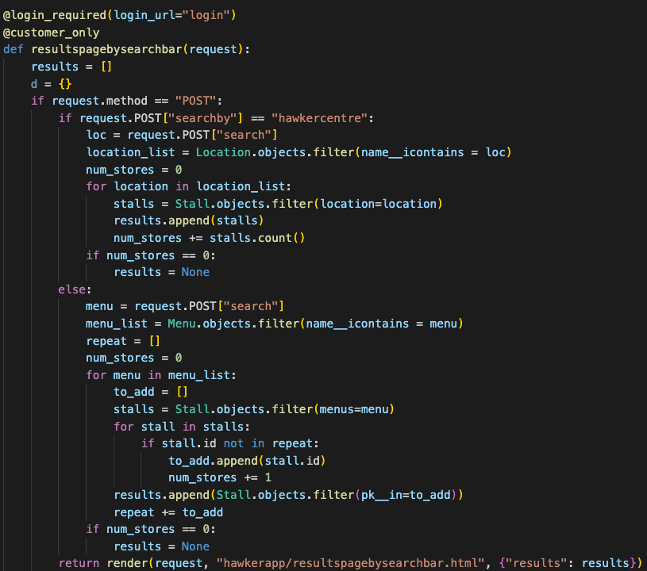

# Appendix A: Data Dictionary

| **Field Name** | **Data Type** | **Data Format** | **Field Size** | **Description** | **Example** |
| --- | --- | --- | --- | --- | --- |
| Hawker Centre | Text | - | 100 | An open air market at which individual vendors sell ready-to-eat food from small booths | Maxwell Food Centre |
| Hawker Stall Owner | Text | - | - | A person who owns hawker stall(s) | - |
| Customer | Text | - | - | A potential patron of hawker stall(s) | - |
| Account | Text | - | - | A unique profile that stores a user’s personal information and saved information in the app | - |
| Unique Account Username | Text | - | 20 | A unique identifier used to gain access to a computer, network or online system | Lim Jun Jie |
| Account Password | Text | At least 8 characters with a mixture of letters and numbers and inclusion of at least one special character | 20 | A string of characters used to verify the identity of a user during the authentication process. | 8xiJ55KE#oz |
| Rating | Category | Integer value from 1 to 5 | 1 | Classification of a hawker food stall based on the user’s impression of their food | 3 |
| Review Description | Text |  | 200 | Written remark expressing an opinion or reaction of a hawker food stall by the user | Fresh fish soup with rice, porridge, or bee hoon is available. The soup broth was delicious, and it was cooked to perfection |
| Distance | Integer | Kilometers | 2 | Physical distance between the user and the desired hawker  centre | 3.2 kilometers |
| Region | Category | North, North-East, South, East, West or Central | 20 | Urban planning subdivisions demarcated by the Urban Redevelopment Authority of Singapore | North-East |